Spring Question

**Tight Coupling:**

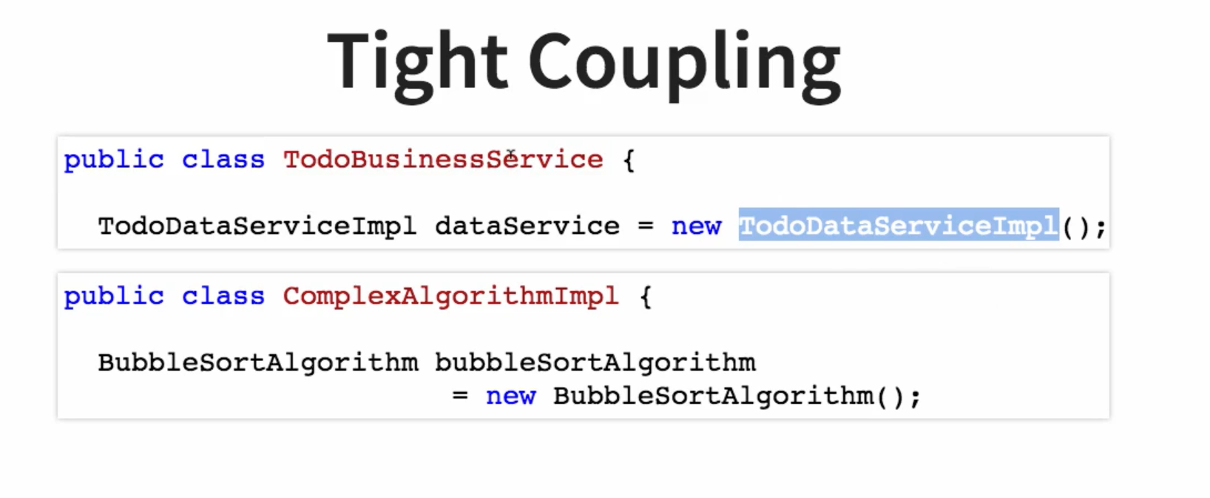

**Loose Coupling**

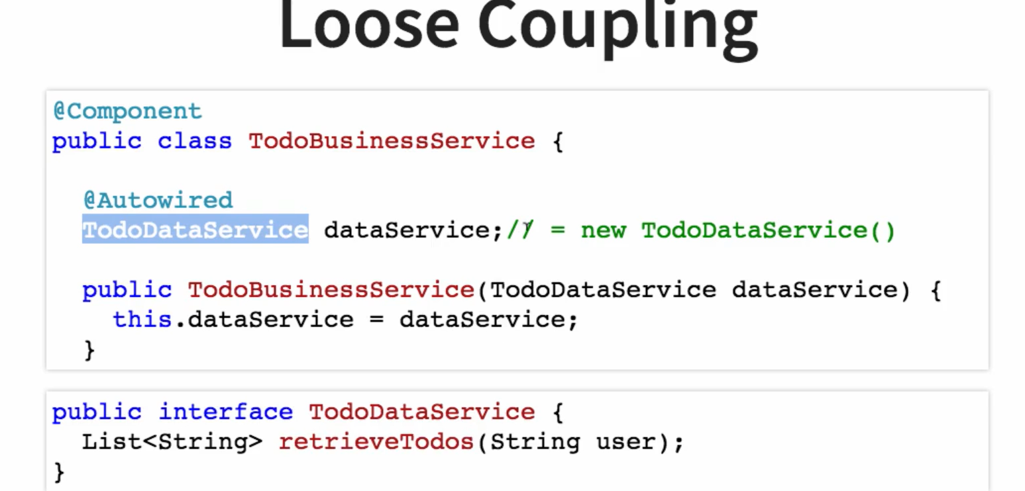

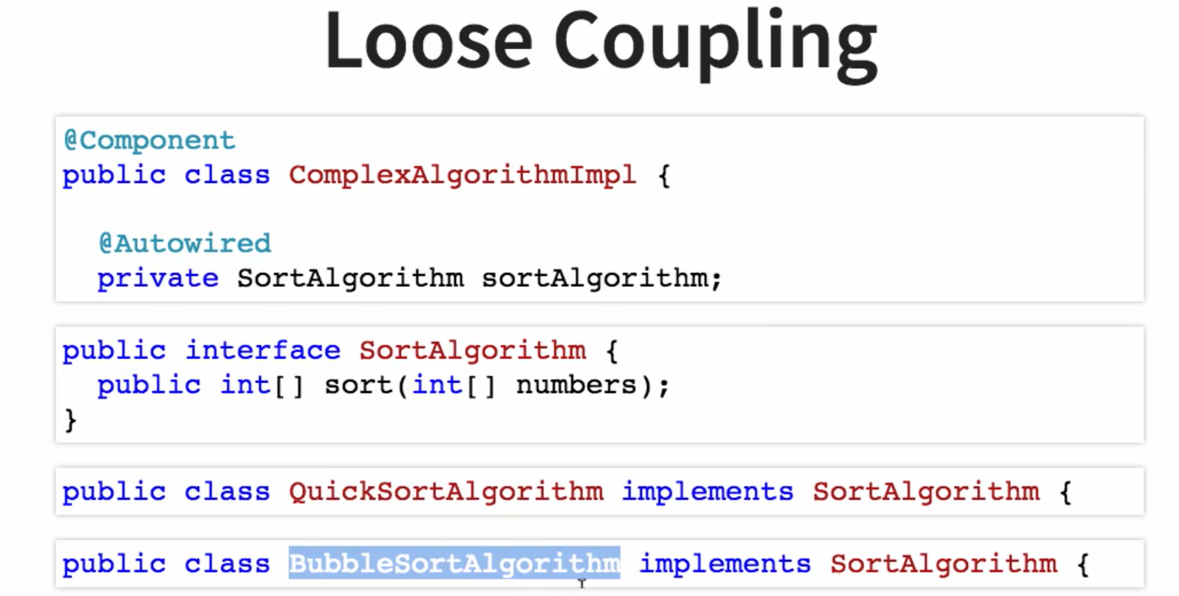

**What is Dependency?**

A dependency is an external library or module that a project relies on to perform specific tasks.

**What is Dependency Injection?**

Spring Dependency Injection (DI) is the feature of the core module of the Spring Framework, where the Spring Container injects other objects into an object. Here, other objects are nothing but dependencies (instance variables) which are declared in the class (Spring Bean)

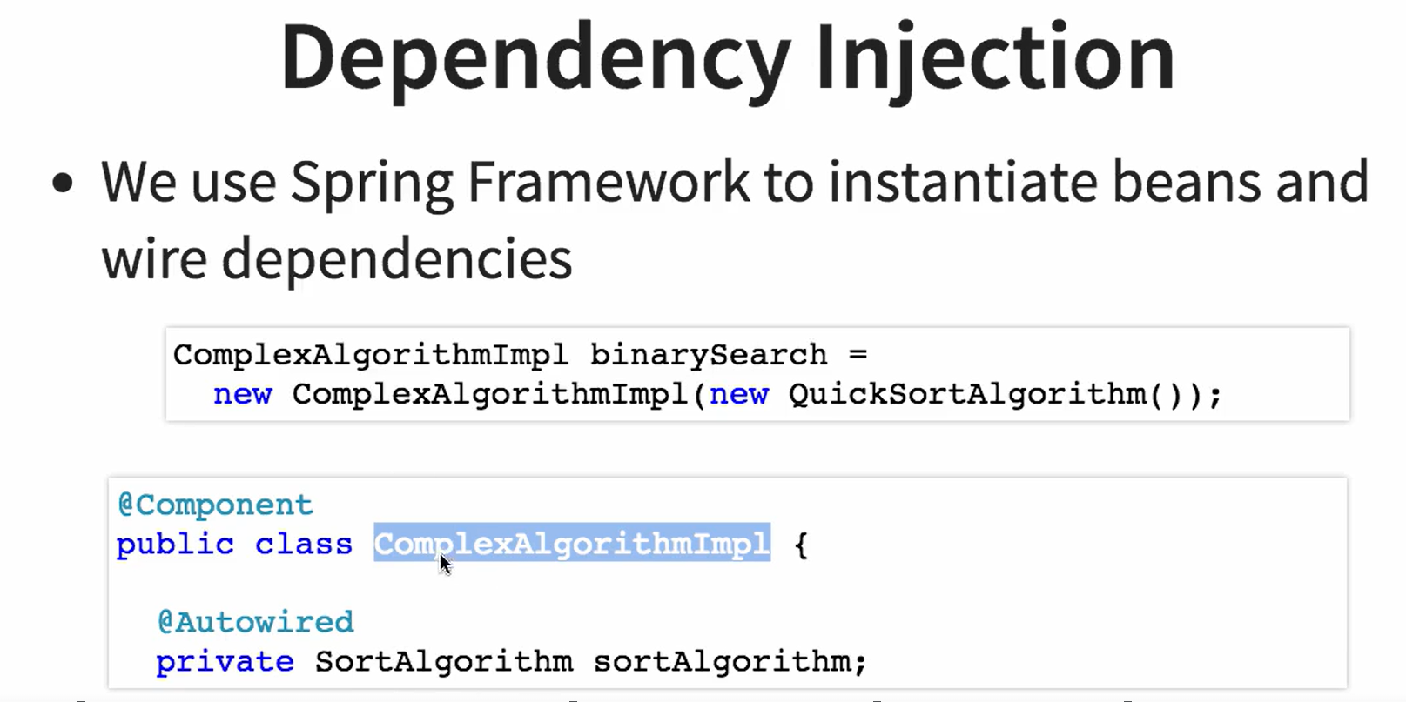

**IOC (Inversion of Control):**

DI is based on the Inversion of Control (IoC) principle, which involves transferring the control of objects or a block of a program to a container or framework.

**What is Autowiring?**

@Autowired is a mechanism by which Spring Boot automatically resolves and injects collaborating beans into your objects. This feature is part of Spring's inversion of control (IoC) container that manages the lifecycle and configuration of application objects

@Autowired annotation is Used.

IOC Container:

Below are the Roles for IOC Container-

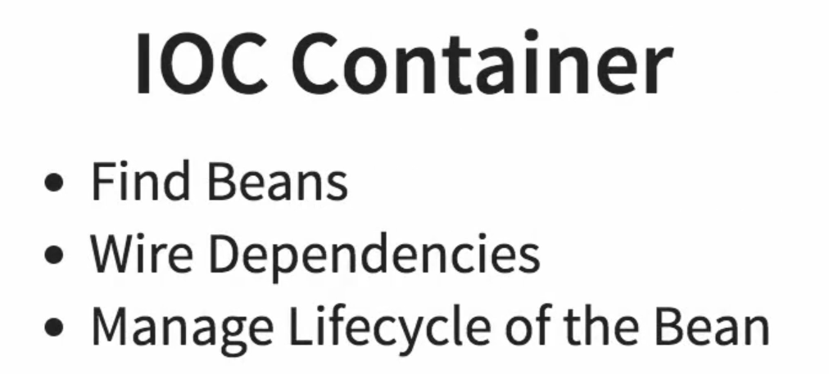

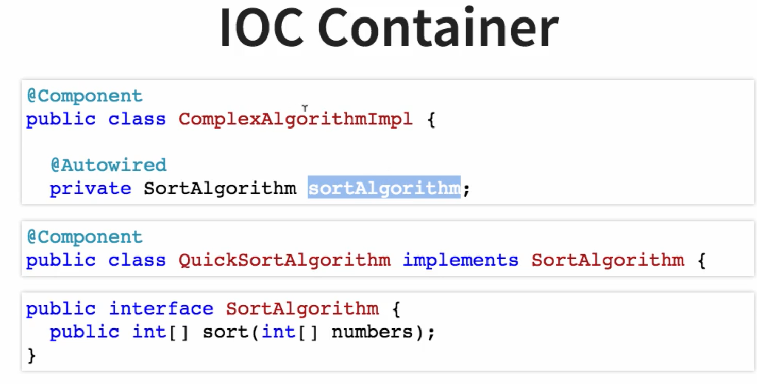

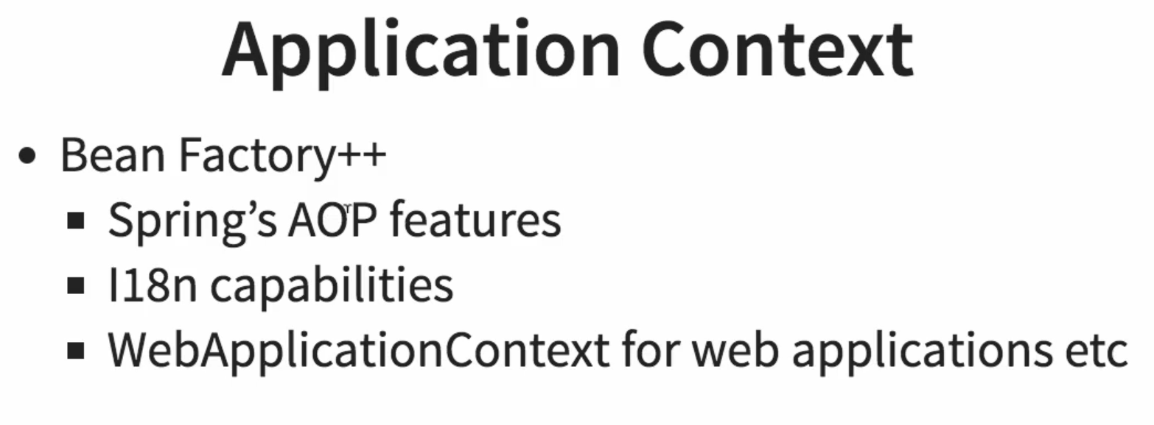

**Q. How to Create an Application Context Using Bean?**

Using XML or Using @Configuration Annotation

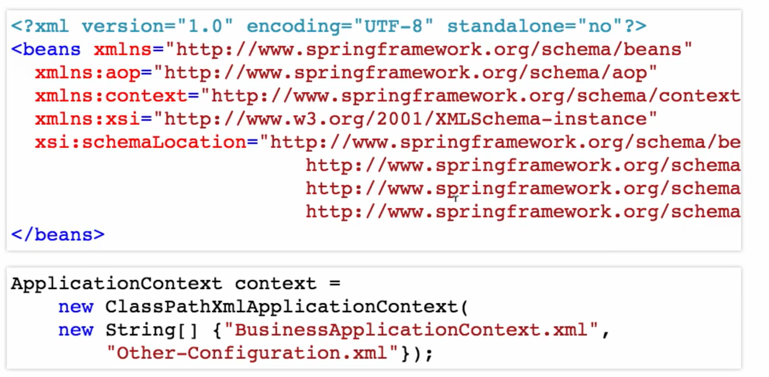 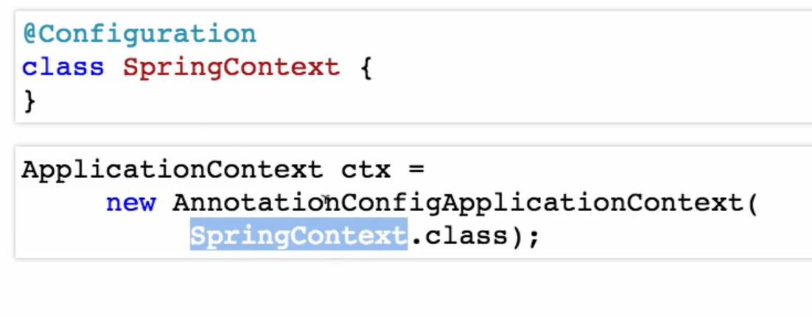

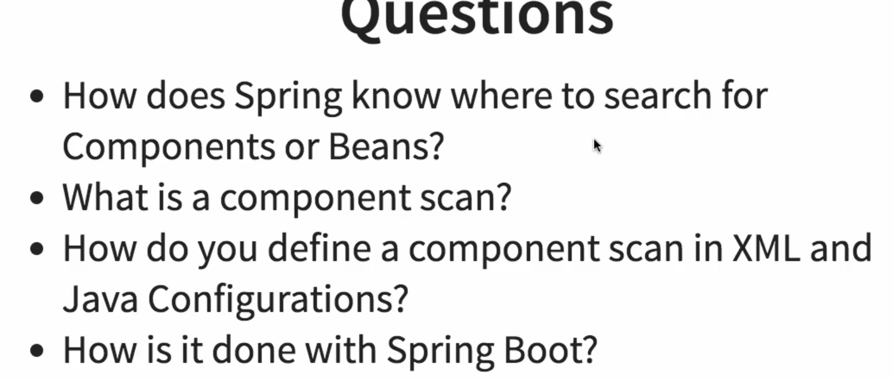

**Q. How does Spring know where to search for Components or Beans?**

Using @**ComponentScan**

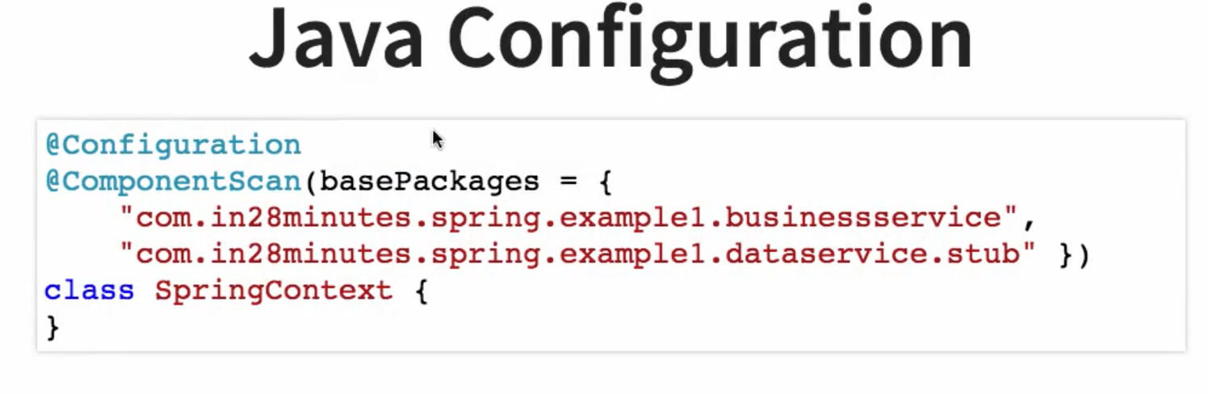  
Using XML,

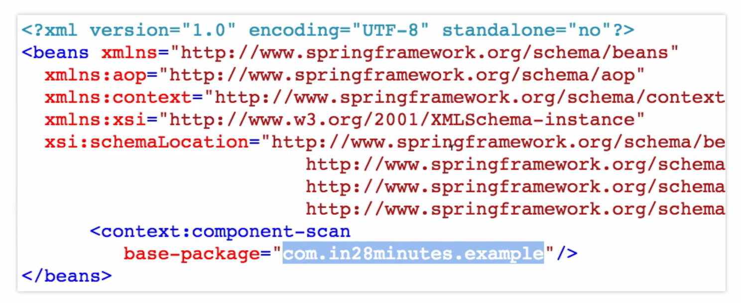

In Springboot, we use @SpringBootApplication Annotation **for @Configuration, @EnableAutoConfiguration, and @ComponentScan.**

**Annotations:**

@Component: Spring Should manage the Bean. Most Generic

@Autowired: Spring should Find the matching bean and wire the Dependency in.

@Service: Business Service Façade. Used in Business Layer

@Controller: Controller in MVC pattern. Used in Web Layer

@Repository: Typically used at Data Layer. Encapsulating Storage, retrieval and search behaviour typically from a Relational database

**Q. What is the default scope of a Bean?**

There are below Scope,

Singleton – One Instance per Spring Context – **DEFAULT SCOPE**

Prototype – New bean whenever requested

Request – One bean per HTTP Request. Web – Aware Spring ApplicationContext.

Session – One bean per HTTP Session. Web – Aware Spring ApplicationContext

**Q. Are Beans Thread Safe?**

beans aren't thread-safe

**Q. What are the other Scope Available?**

prototype", "request", "session", "application", and "websocket"

Type of Dependency Injection:

Setter Injection –

Thr Setter method which we provide.

Contructor Injection –

Prefer

Provide Immutability

Q. Configuration-

Configuration can be done by XML or Java

In XML, Manually need to Describe All Configuration

In Java, Using Annotation can be Done.

**Autowiring**:

* byType – Class or Interface

@Autowired

**private SortAlgo sortalgo**;

* byName - There Multiple Class Implemented Same Interface then java detect the Autowiring using name of the Class.

@Autowired

**private SortAlgo quickSort**;

* Constructor – Similar to byType but through Constructor

Q. What is @Primary?

Used to designate a preferred bean among multiple beans of the same type.

Q. What is @Qulifier?

Used to specify a specific bean that should be injected into a field, constructor, or method parameter.

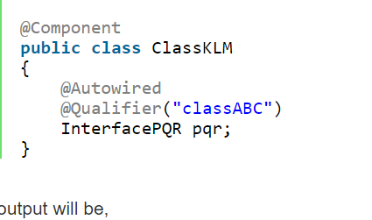

CDI:

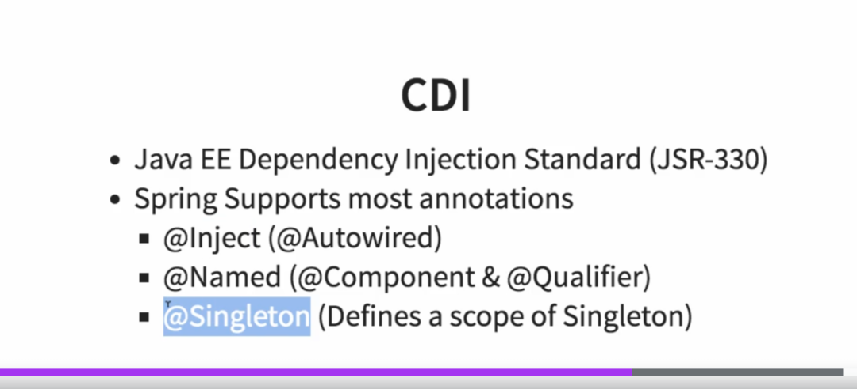

Notes:

